PROJECT DOCUMENTATION

FITFLEX-YOUR FITNESS

INTRODUCTION

TEAM MEMBERS:

1.GANDHIMATHY D  [-gandhimathy27200@gmail.com](mailto:%20-gandhimathy27200@gmail.com)

2.JASMINE FARHANA S [–jfarhana2810@gmail.com](mailto:–jfarhana2810@gmail.com)

3.DHARSHINI M [–mohanjagann2000@gmail.com](mailto:–mohanjagann2000@gmail.com)

4.KEERTHANA D- [keerthanadillibabu2007@gmail.com](mailto:keerthanadillibabu2007@gmail.com)

SOURCE CODE:

import React from 'react';

import { createRoot } from 'react-dom/client';

import { BrowserRouter } from 'react-router-dom';

import App from './App';

import './styles/app.css';

const container = document.getElementById('root');

const root = createRoot(container);

root.render(

<BrowserRouter>

<App />

</BrowserRouter>

);

Output ScreenShot

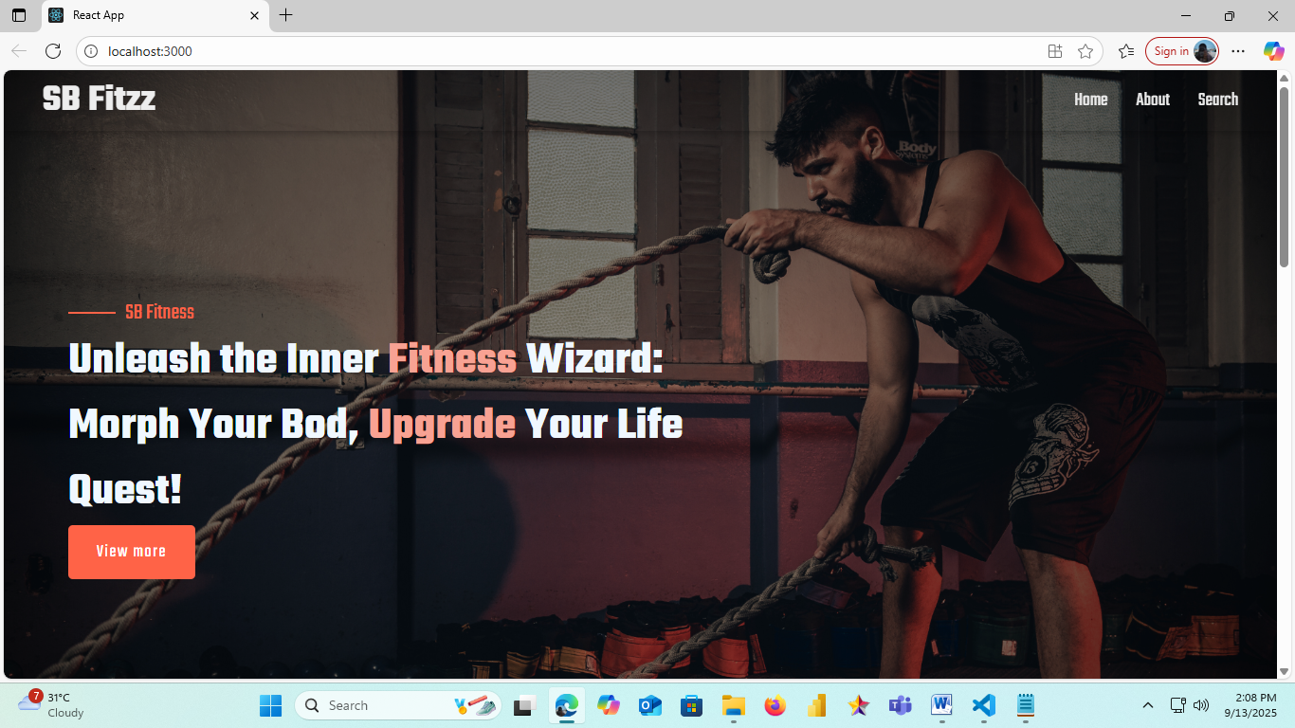

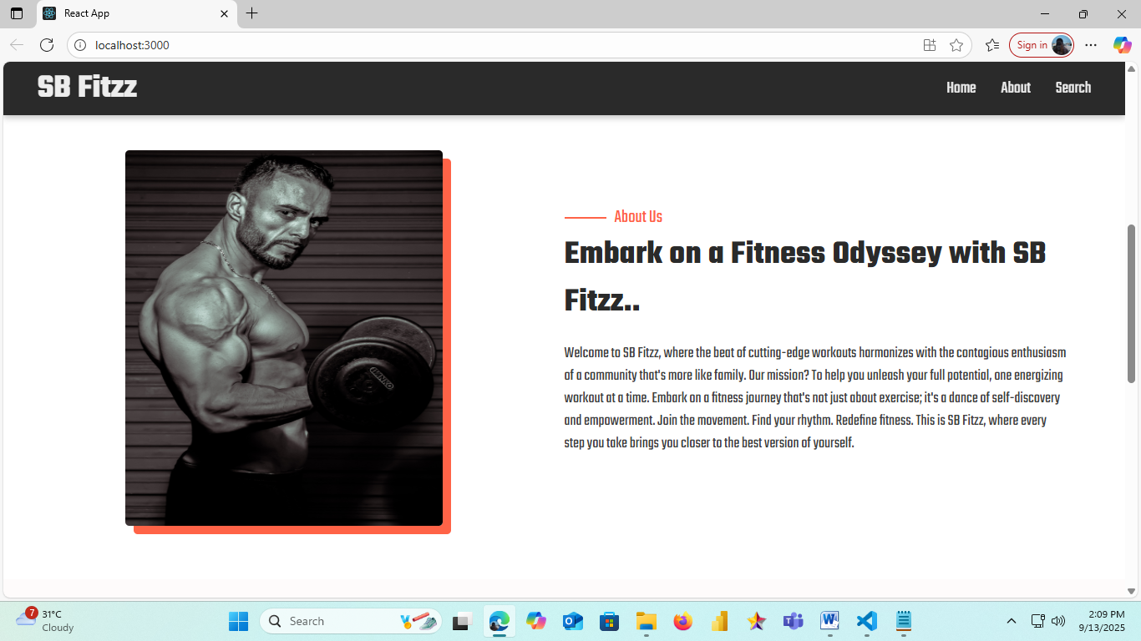

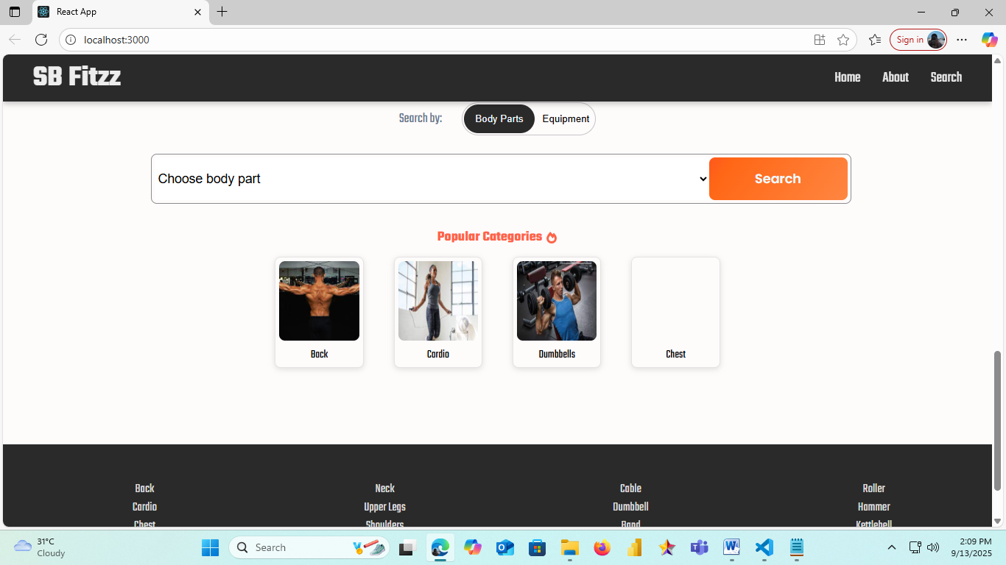

Demo Link :

<https://drive.google.com/file/d/1F7g1fcru7Sv-gXZ51T2Htir7ErJauH0w/view?usp=drivesdk>